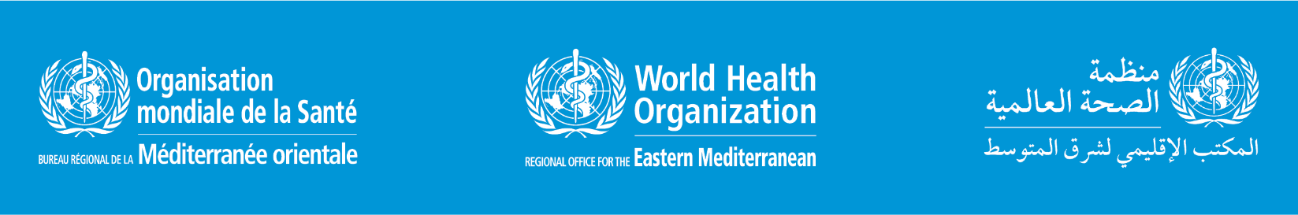

**Invitation to the media**

**WHO Virtual Press Conference**

**Update on COVID-19 and monkeypox situation in the Eastern Mediterranean Region**

**Wednesday, 22 June 2022, 15:00 Cairo time (GMT+2)**

**What**:

The media briefing will highlight the COVID-19 and monkeypox situation in the Eastern Mediterranean Region

**Who:**

* Dr Ahmed Al-Mandhari, WHO Regional Director for the Eastern Mediterranean
* Dr Richard Brennan, Regional Emergency Director, WHO Regional Office for the Eastern Mediterranean
* Dr Abdinasir Abubakar, Manager, Infectious Hazard Prevention and Preparedness, WHO Regional Office for the Eastern Mediterranean
* Dr Shaza Mohamed, Medical Officer, Infectious Hazards Prevention and Preparedness, WHO Regional Office for the Eastern Mediterranean

**When:**

Wednesday, 22 June 2022, 15:00 Cairo time (GMT+2)

​**How:**

The virtual press conference will be streamed on Zoom, with simultaneous translation available in English and Arabic. To ask questions to panelists during the press briefing, please register here:

<https://who.zoom.us/webinar/register/WN_6bTC4B2rSSOwml_6WOsPcQ>

If you prefer to submit questions in advance, please fill in the form at: <http://www.emro.who.int/askemro>

Additionally, the event will be livestreamed on:

* **Facebook    [Arabic Livestream]**: [www.facebook.com/WHOEMRO](http://www.facebook.com/WHOEMRO)
* **YouTube     [Arabic Livestream]:** [www.youtube.com/whoemr](http://www.youtube.com/whoemr)
* **Twitter       [English Livestream]:** [www.twitter.com/WHOEMRO](http://www.twitter.com/WHOEMRO)

